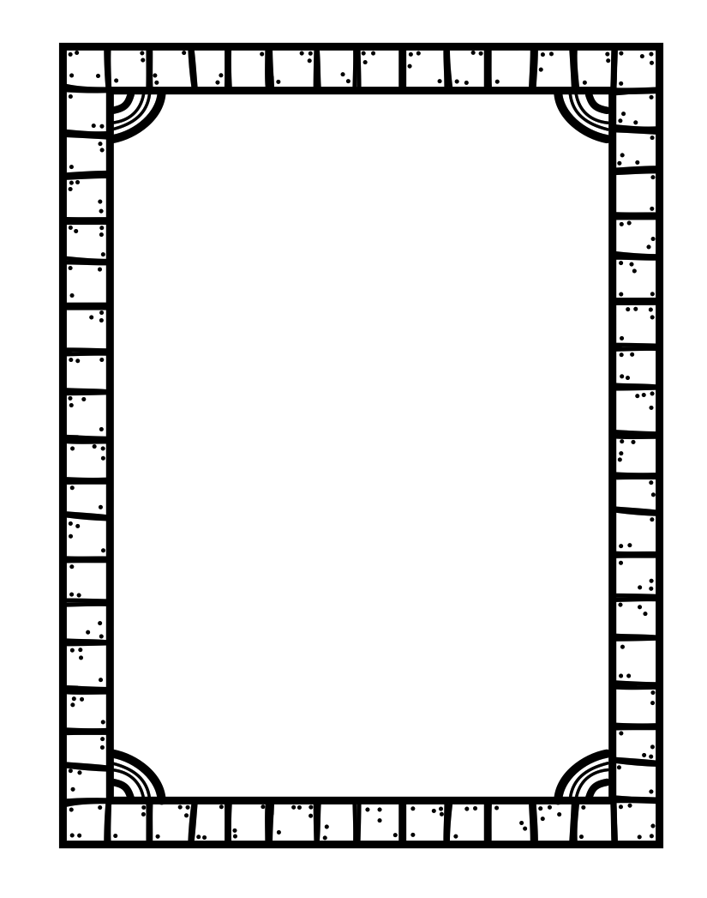

Name ____________________ Class _______

Why do cats knead?

Knead means to massage or squeeze with the hands or paws.
After searching for answers, I learned that ________________________________________________________________________________________________________________________________________________________________________________________________________________________________________________________________________________________________________________________________________________________________________

